**St Eunan’s Cathedral, Raphoe**

**Services & Events – March 2025**



*Mid-week Lent Services begin on*

*Ash Wednesday – see details*

*of all Lenten Services overleaf*

**Sunday 2nd March**

*12 noon – Baptism & Holy Communion*

**Sunday 9th March**

*12 noon - Service of Morning Prayer*

**Sunday 16th March**

*12 noon - Service of Morning Prayer*

**

***Monday 17th – St Patrick’s Day*** *HC @ 10.30am*

**Sunday 23rd March**

*12 noon - Service of Morning Prayer*

**Sunday 30th March**

*11am – Confirmation Service*

**Other Dates/Notes:**

***Raphoe MU Meeting -*** *Tues 4th March @ the Deanery, 2pm*

***Cathedral Quiz – Friel’s Hotel –*** *Thurs 6th March @ 8pm*

***World Day of Prayer Service –*** *St Eunan’s Chapel, Raphoe, 7pm*

***Raphoe Select Vestry Meeting -*** *Tues 11th March, 8pm*

***Easter General Vestry Meeting -*** *Tues 8th April, 8pm*

***Easter Draw/Coffee Morning -*** *Sat 12th April, 11am (Draw @ 12.30pm)*

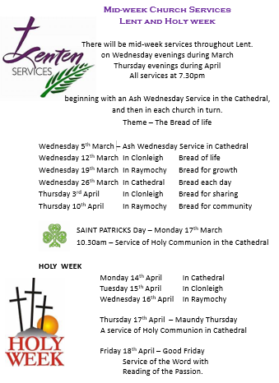



***SAFEGUARDING***

*The welfare of children and vulnerable adults is of paramount importance. If there are any concerns about safeguarding or issues, please contact Dean Liz and/or one of the panel members below.*

*Averil Meehan - Clonleigh*

*Elaine Doherty - Raymochy*

*Gladys Barnett - Raphoe*

*Des West – Raphoe*

*Dean Liz FitzGerald – Rector*

*Contact details can be found on the church noticeboard.*



*Updated 3.3.2025*