**St Eunan’s Cathedral, Raphoe**

**MAY NEWSLETTER**

**Sunday Services – 12 noon**

|  |  |  |
| --- | --- | --- |
| 4th May | 3rd Sunday of Easter | Holy Communion |
| 11th May | 4th Sunday of Easter | Morning Prayer |
| 18th May | 5th Sunday of Easter | Holy Communion |
| 25th May | 6th Sunday of Easter | Children’s Day |

**Other Services**

|  |  |
| --- | --- |
| Thursday 29th May  10.30am | Ascension Day  Holy Communion |

**Upcoming Evening Services**

|  |  |
| --- | --- |
| Friday 6th June – 7.30pm | Mothers’ Union Diocesan Festival Service with Commissioning and incorporating the All Ireland Holy Communion service |
| Wednesday 11th June | Service of Ordination |
| Tuesday 24th June | Installation of Canon Skuce |

|  |
| --- |
| **Members of the Select Vestry - 2025/26**  Dean Liz FitzGerald, William Laird [Rector’s Churchwarden],  Gareth Goudie [People’s Churchwarden], Geoffrey Devenney [Rector’s Glebewarden], Alexander Freen [People’s Glebewarden],  Colvin Beattie [Supp. People’s G-warden], Jim King [Supp. Rector’s G-warden], Elizabeth Barnett, Edwin Barnett, Gladys Barnett, Des West, Joy Rutherford, Margaret Parke, Lorraine Laird, Renee Goudie [Hon. Secretary], Rodney Lindsay [Hon. Treasurer], Geraldine West  *Date of next meeting: Wednesday 14th May 2025 @ 8pm* |

***Some of the lovely window displays in the Cathedral for Easter 2025***

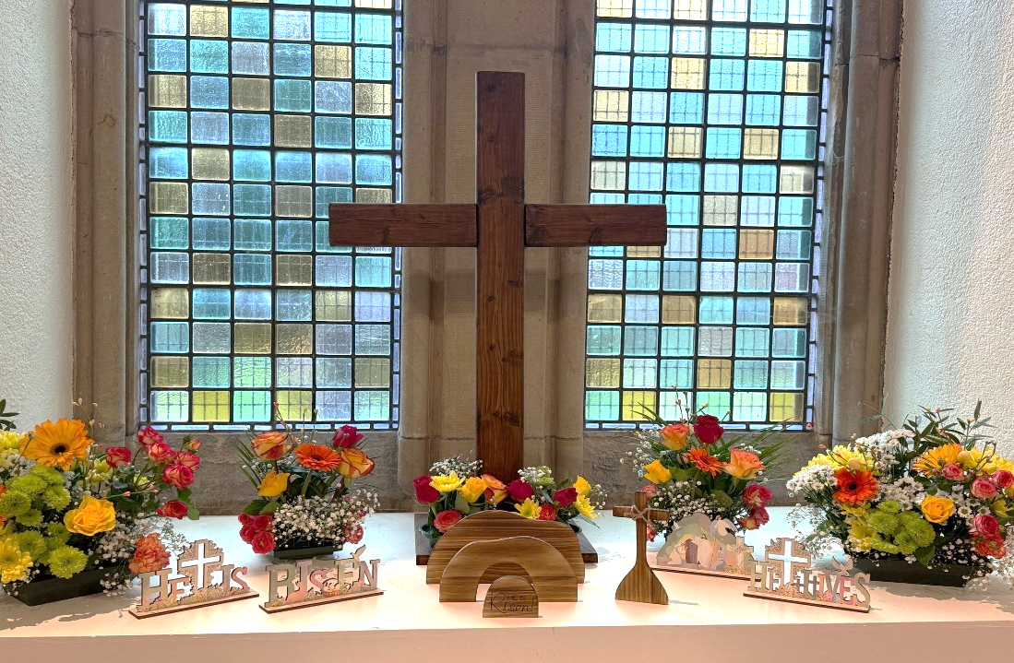

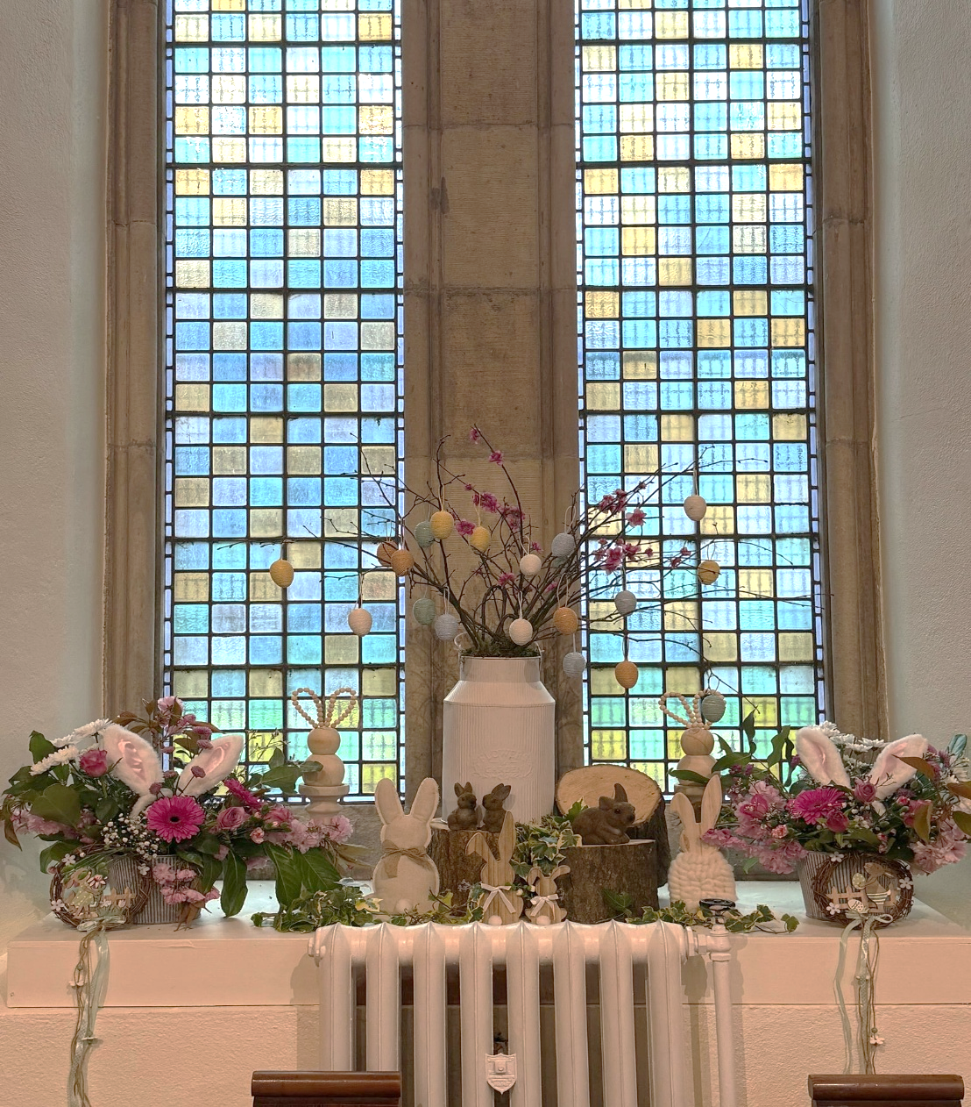

*-------------------------------------------------------------------------------------------------*

***SAFEGUARDING***

*The welfare of children and vulnerable adults is of paramount importance. If there are any concerns about safeguarding or issues, please contact Dean Liz and/or one of the panel members below.*

*Averil Meehan - Clonleigh*

*Elaine Doherty - Raymochy*

*Gladys Barnett - Raphoe*

*Des West – Raphoe*

*Dean Liz FitzGerald – Rector*

*Contact details can be found on the church noticeboard.*

*--------------------------------------------------------------------------------------------------------------------------------*

***Cathedral webpage:*** cathedral.raphoe.anglican.org